Transferable skills. Example 3: The mental health nurse
Finding evidence of transferrable skills from every day experiences can be much easier than you think. This example should help you to understand and identify your own transferrable skills.
Meet Ethan.
Ethan is 19. When he first left school he wasn’t sure what he wanted to do but now Ethan has decided to apply to become a mental health nurse.
Ethan is studying an Access to Higher Education course.
Ethan works part time as a crowd safety steward at Sheffield Wednesday FC. He also does some hours as a bartender for the club. He recently completed an NVQ2 Level 2 Certificate in Spectator Safety with the club. As a steward he has learnt how to use observation and communication to manage people’s behaviours. The NVQ covered crowd control, conflict management and responding to accidents and emergencies and he gets to practice these skills in his work quite regularly.
Ethan is a keen supporter of Sheffield Wednesday. He used to play for their U18 team. He still plays football for a local club and is quite a good goal keeper. In fact he takes part in his club’s summer school for under 12’s, teaching goal keeping skills and general fitness.

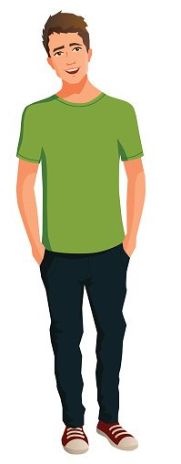

Mental Health Nurse’s Skills
According to NHS Careers to be a mental health nurse academic qualifications are required, but they aren’t everything Mental health nurse | Health Careers. Communication and interpersonal skills are crucial, as well as strong judgement, and being able to teach, advise and manage people.

Picking out the required skills:
- Communication and interpersonal skills
- Strong judgement
- Able to teach
- Able to advise
- Able to manage people

Now we can match the required skills to Ethan’s own life experiences
- Communication and interpersonal skills
Ethan will use learning and evidences from his NVQ. He chooses an example from his job as a crowd safety steward to show how he has used his communication skills in a real world setting and how he has helped to diffuse or improve a situation. (This would be an example of how Ethan has applied theory from the course into his practice as a steward).
- Strong judgement
Ethan chooses to use an example from his bar work. He tells of a night where one customer was fairly drunk and she was getting aggressive with other guests whilst waiting at the bar. Ethan noticed this. He took her order and then told her to have a seat and he would bring it over. Once he had served the next couple of customers, he took a large glass of water over to her, along with a sandwich from the buffet. She was already a little calmer and he was very kind to her when he offered her the sandwich and water, saying he thought this might make her feel better. Ethan feels that removing her from the situation and being kind really was the best course of action.
- Able to teach
Ethan teaches goalkeeping and fitness skills to young people.
- Able to advise
He advises and coaches young people in the summer schools. In each case he has to assess the abilities and skills of each child and advise a suitable plan to help that child develop those skills to the next level.
- Able to manage others
Ethan’s crowd management skills, knowledge and experience are all highly relevant here. He will also find examples from managing groups in the summer school so that every child is engaged, included and feels able to take part.

Now you have worked through Asa’s example, have a go at identifying your own transferrable skills

Now you have worked through Ethan’s example, have a go at identifying your own transferrable skills.
You can look on https://www.healthcareers.nhs.uk/ and Think Care Careers (skillsforcare.org.uk) sites to find the sort of skills needed for your own preferred job in the Health and Social Care sector.
~~~~ ~~~~

