Key Stage 2 Healthcare Science Presentation:
Guidance notes

Session resources: These notes accompany slides KS2Healthcare Science Ambassador PowerPoint
Session duration: 40-60 minutes.
Target Audience: Key Stage 2 (upper primary ages 7-11)
Group size: 1 class of up to 30 students, or a year group of 60 or 90 pupils together
Location: In school
Personnel: One or two Healthcare Scientists/trainees. Teacher must be present throughout the session.
Objectives
- To inspire and intrigue young people on the topic of science in healthcare
- To introduce the idea that real people get to work in these exciting roles
- To help young people see themselves in those roles and want to aspire to become a Healthcare Scientist
This is a tried and tested model to engage students in this age group. The ‘guess the image’ slides can be adapted to suit different job roles in science. Depending on the role you are focusing on, you may choose to take physical props into the session too.
The trick is to grab the students attention from the start. Use age-appropriate language and imagery to keep their interest. Our session gives students lots of opportunities to contribute using their existing knowledge whilst learning more about our sector and the roles available.
Top Tips:
- smile
- keep the session live, interactive and engaging.
- allow pupils time to respond to your questions.
- be equally positive about both right and wrong guesses.
- some excitement in the room is to be expected, especially when talking about football or showing potentially gory images. The teacher will help if students become too animated.
- it doesn’t matter if you are talking about job areas/images that are nor your area of specialism, you will know lots more than your audience and they will still be intrigued.
Starting the session
Presenters to introduce themselves.
Say that you are here to talk about jobs in the NHS and Social Care. This includes places like hospitals, care homes, doctors’ surgeries and much more. You might be surprised just how many jobs we have!

Activity 1: Football club analogy
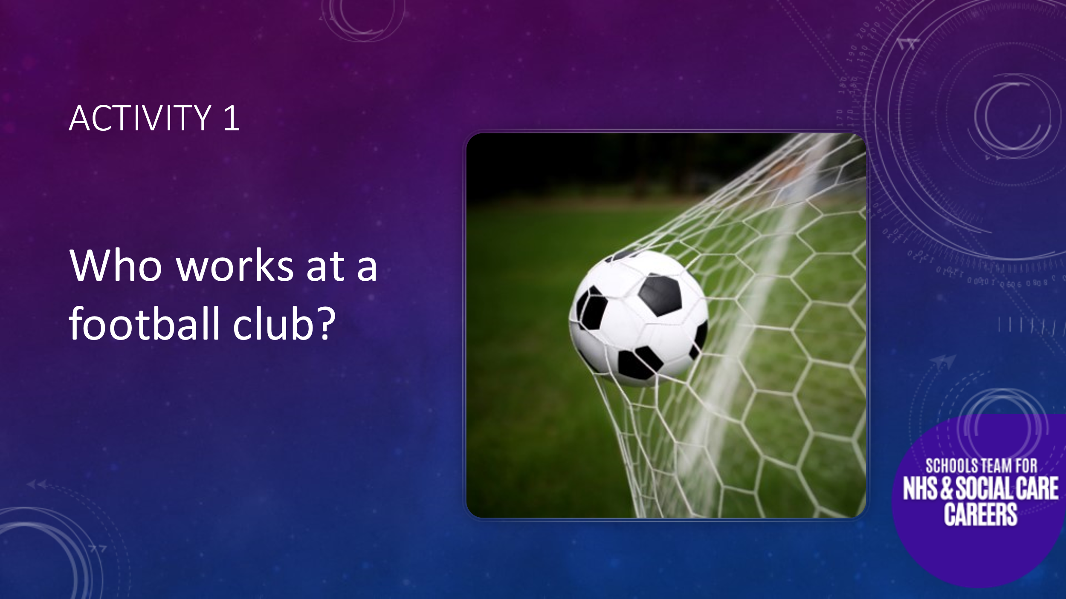
Ask students if anyone likes football. “So, before we start, who likes football?”
Ask what teams they support. Refer to local teams such as Sheffield Wednesday, Sheffield United, Doncaster Rovers or Premiership teams such as Manchester United, Manchester City, Arsenal, Liverpool etc. this will create a buzz.
Go on to say: You might be wondering why we are talking about football? Well, all organisations have a workforce including football clubs. We’d like you to think about all the different jobs which happen in a football club, think about the physical building, who looks after the players, events that might take place and who’s on hand on match day. Think about how the club promotes itself too!
Ask students who they think works in a football club. We find this works best as a discussion. There is no real need to record the responses, but we tended to expand on some or summarise the range of jobs identified as we went along. Once the obvious roles like players, manager and coach are out of the bag prompt them by asking things like:

How do the players get to away games (coach driver)
Who cuts the grass on the pitch? (Grounds person)
Who sells tickets? (Ticket office staff)
Do the players take their kit home for their mums to wash? (Kit Manager)
Who pays the players? (Payroll/finance staff)
Who is responsible for crowd control (Stewards)
Who provides food/nutrition advice? (Dietitian)
Who helps if a player is injured? Maybe they help with exercises to build up their strength. (Physiotherapist)
What about food and drink? (Hospitality/Events Manager, Catering staff, Waiters, Bar Staff, Chefs, Cleaners etc)
Who sells souvenirs? (Retail staff)
Who plans the fixtures? (Planners)

And the list goes on… it takes a lot of people with different skills and responsibilities to run a football club.

Activity 2: Who works in a Hospital
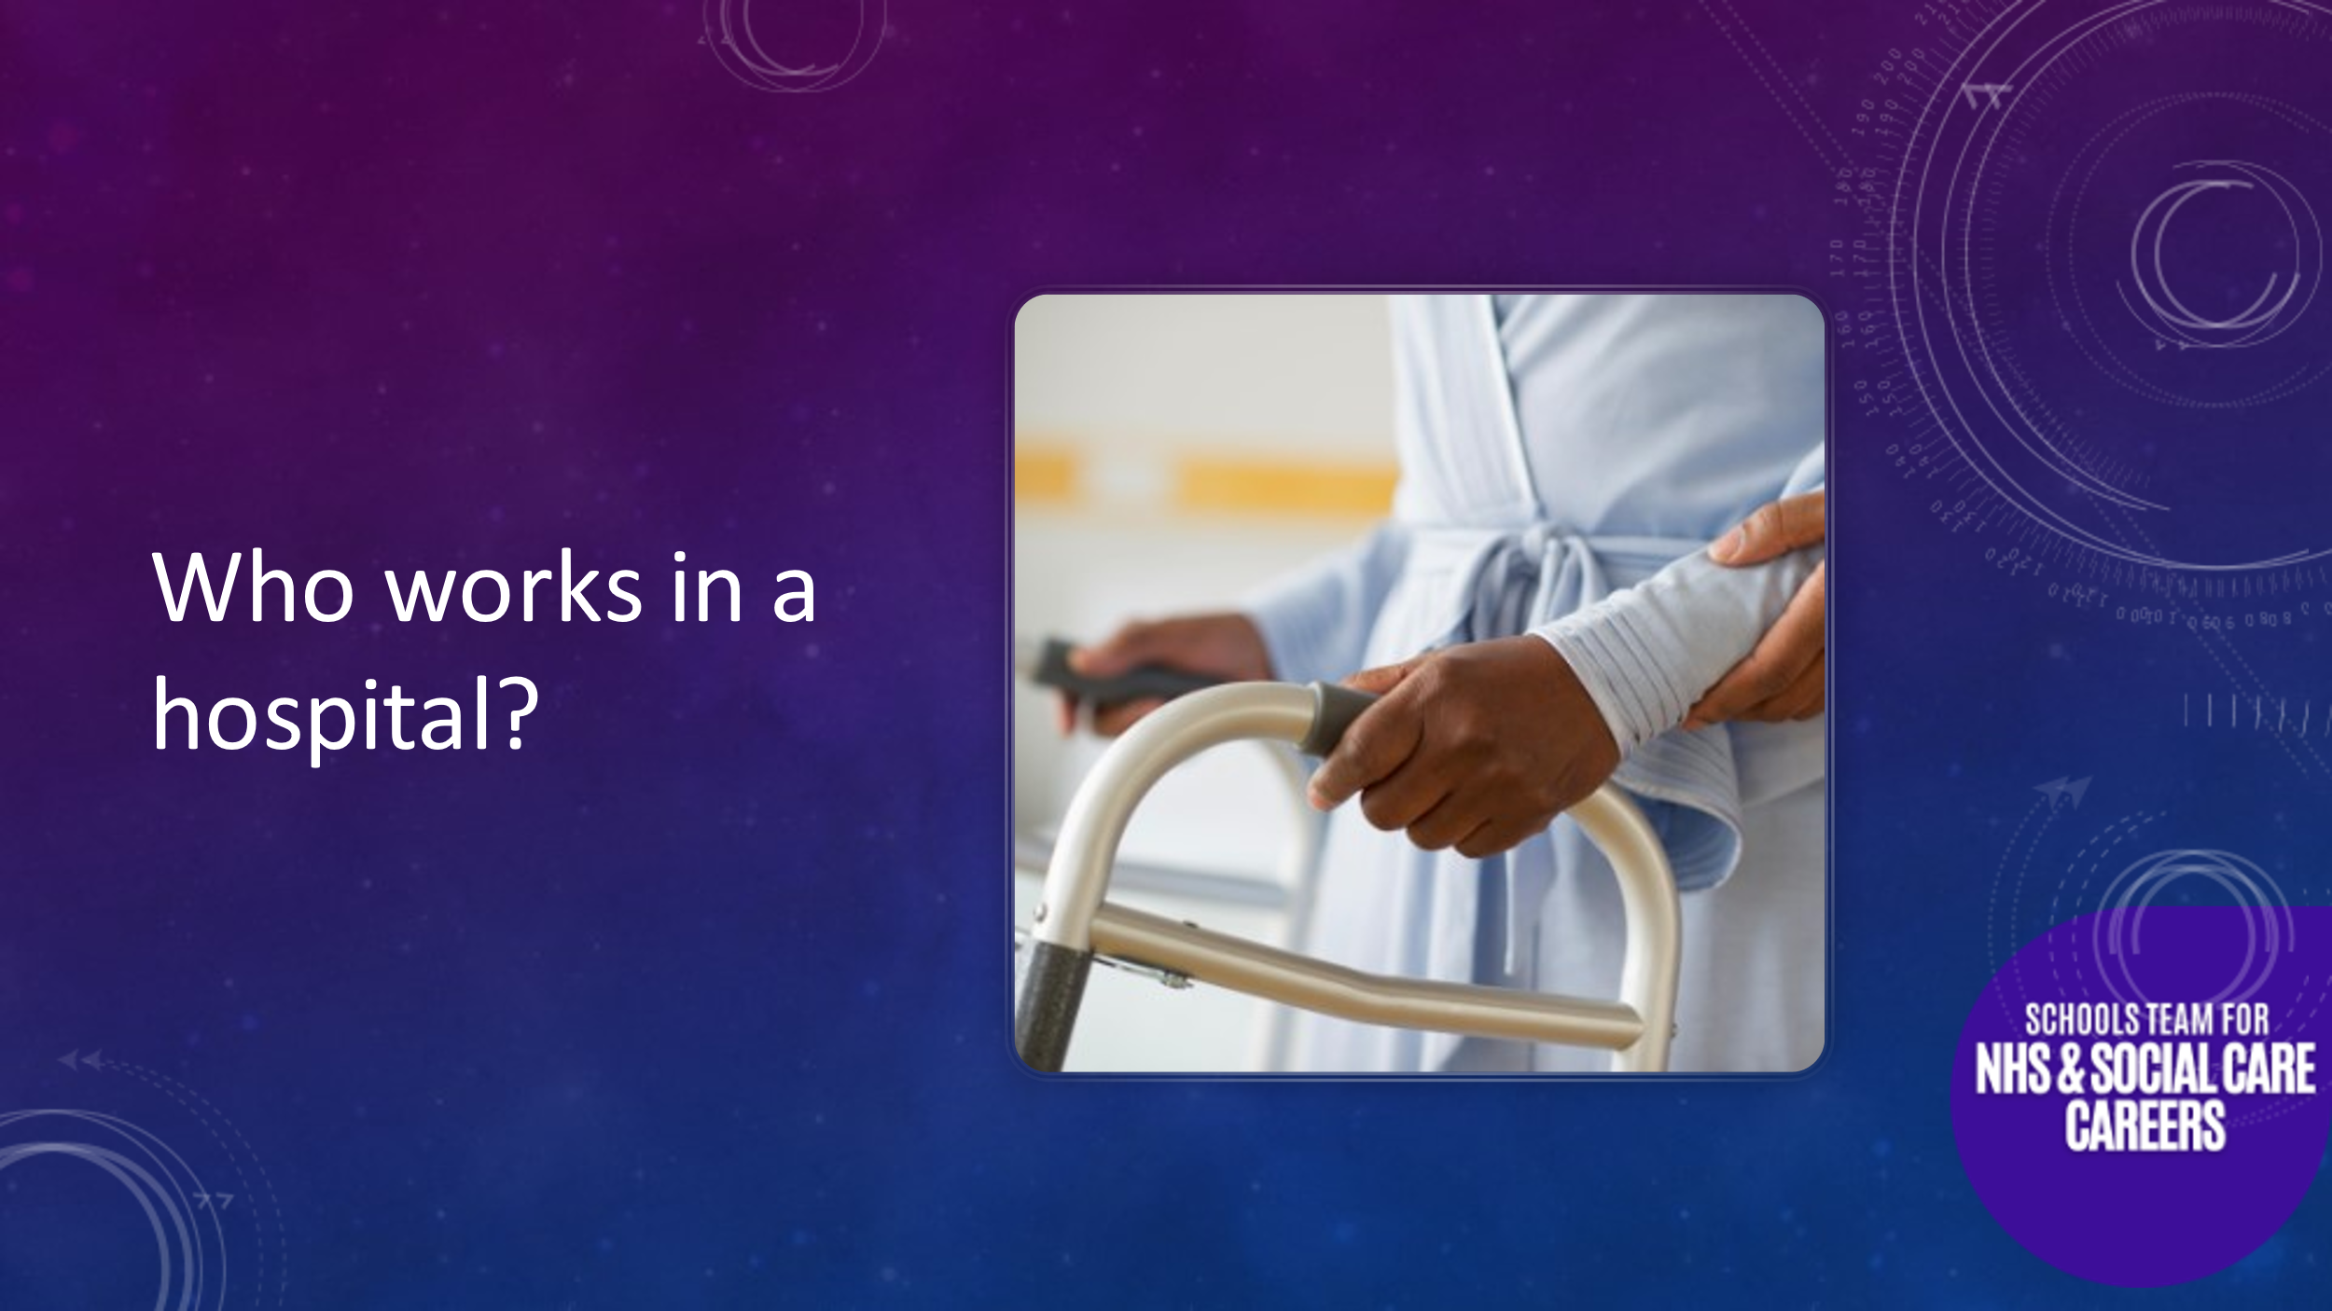
Now we bring it back to the real purpose of our visit and promoting our sector. We refer to that we now know there are lots of different jobs in a football club. Remind them that at the beginning we talked about the NHS and Social Care – this includes hospitals, care homes, doctor’s surgeries and much more.
We repeat the previous exercise but now ask the students who they think works in a hospital? Remind them, it is not just doctors and nurses. Prompt questions may include:

Do you know anyone who works at the hospital? What do they do? (Open question)
Who tests eyes? (Orthoptist/Optician)
Who looks after the computers (IT Technician)
Who washes the bedding and uniforms? (Laundry Assistant)
Who looks after the money? (Accountant/Finance Staff)
Who delivers babies? (Midwife)
Who works in the labs (Scientists)
Who helps people do day-to-day tasks better if they are injured, disabled or poorly? (Occupational Therapist)
Who is responsible for stores/supplies? (Warehouse Manager)
Who greets patients at clinic/doctor’s surgery? (Receptionist)
Who transports patients around the hospital (Porter)
Who makes sure everyone has the right information about patients? (Ward Clerk)
Who takes blood for testing? (Phlebotomist)

And we could go on and on…

Once we have had a decent discussion, covering a range of jobs we explain these are just some of the many jobs. We then ask them to guess how many different jobs they think exist within Health and Social Care? You can prompt with “higher” or “lower” until someone gets close to the answer = 350.
Explain that this is the biggest job sector in South Yorkshire and we believe anyone who wants to can find a role suited to their skills and interests. It just takes commitment and the right training. We need lots of people to work for us. Now we move to the Science focussed part of the session.

A bit about you
At this point you might want to share in a little more detail the work that YOU do and how your work helps patients. Kids love the ‘so what’ side to what you do. Be dramatic. “If I didn’t do my job loads of people …….”

Activity 3: Guess the Image
- The example below is for ‘imaging’ type careers but can be adapted to include microscope images or pictures obtained from cardiac, respiratory, neurosciences etc.
- It’s your job to now walk them through those images in a way that engages and enlightens them and makes the work look interesting.
- It is important that you keep the explanations age appropriate and light touch – see examples below.
- don’t worry too much about job titles, better to say a scientist who specialises in how our heart/lungs/nerves work.

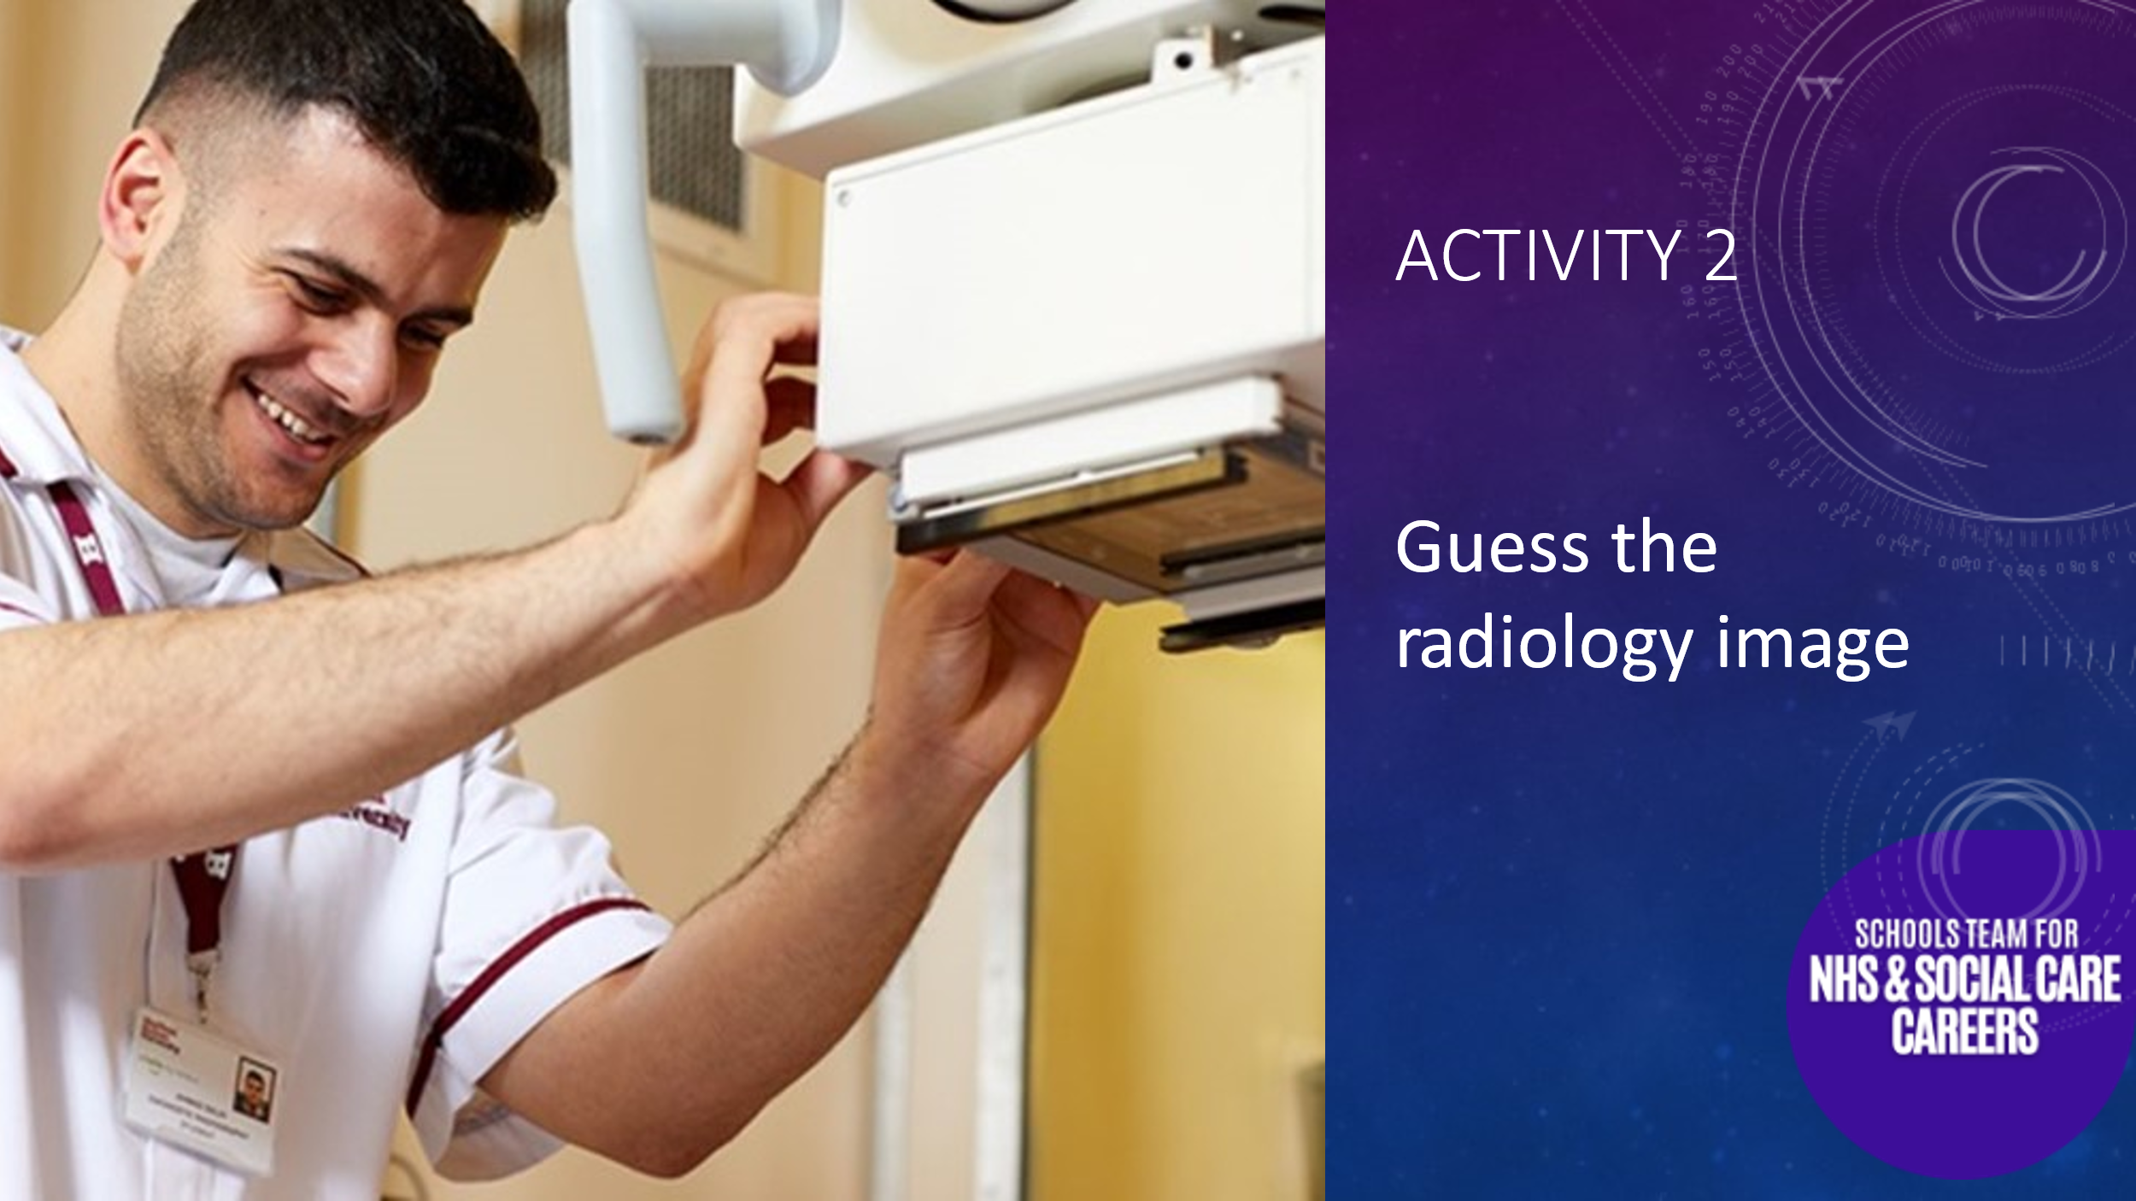
Explain that we will be looking at pictures from inside the body. In each case I want you to tell me what part of the body we are looking at and then we will see if you can tell what is wrong with the patient.

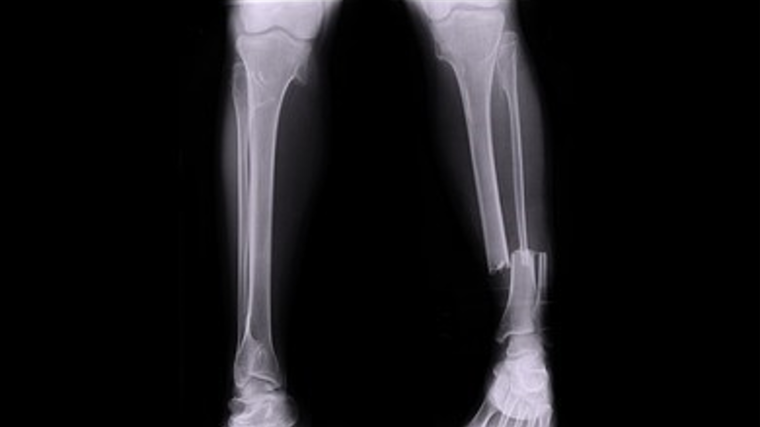 | Body part: Lower leg  Problem: Broken leg  Point out the break – 2 bones. The big bone is the tibia and the smaller bone is the fibula. It’s a nice clean break and should mend nicely!  Don’t forget to be enthusiastic and congratulate them when they get things right! You might also ask students to come up and point out things on the screen for some of the images.
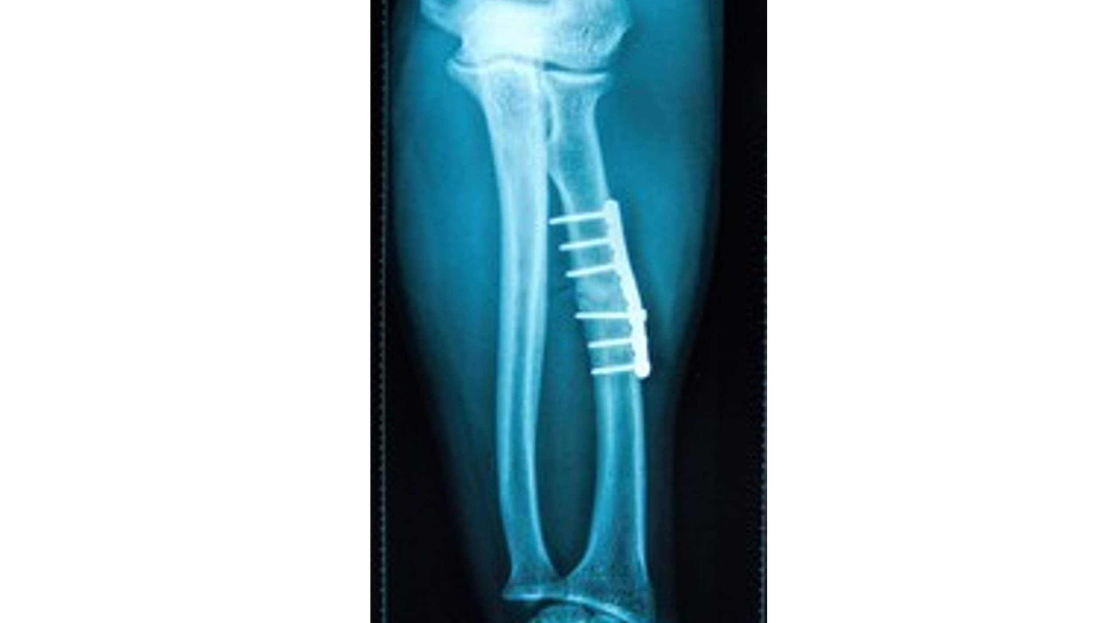 | Body part: Forearm  Problem: Broken arm  But with pins and plate. This is how the broken bone was mended. Sometimes you might just need a cast on your arm or leg and the bones will fix themselves, but if it is a bad break metal pins and plates are used to mend the bone.  The metal shows up bright white on the x-ray. Because it’s a very dense material. The bones are also quite dense but the soft, squishy bits don’t show up much, and this is good because it’s how X-rays help us see what’s going on inside the body.
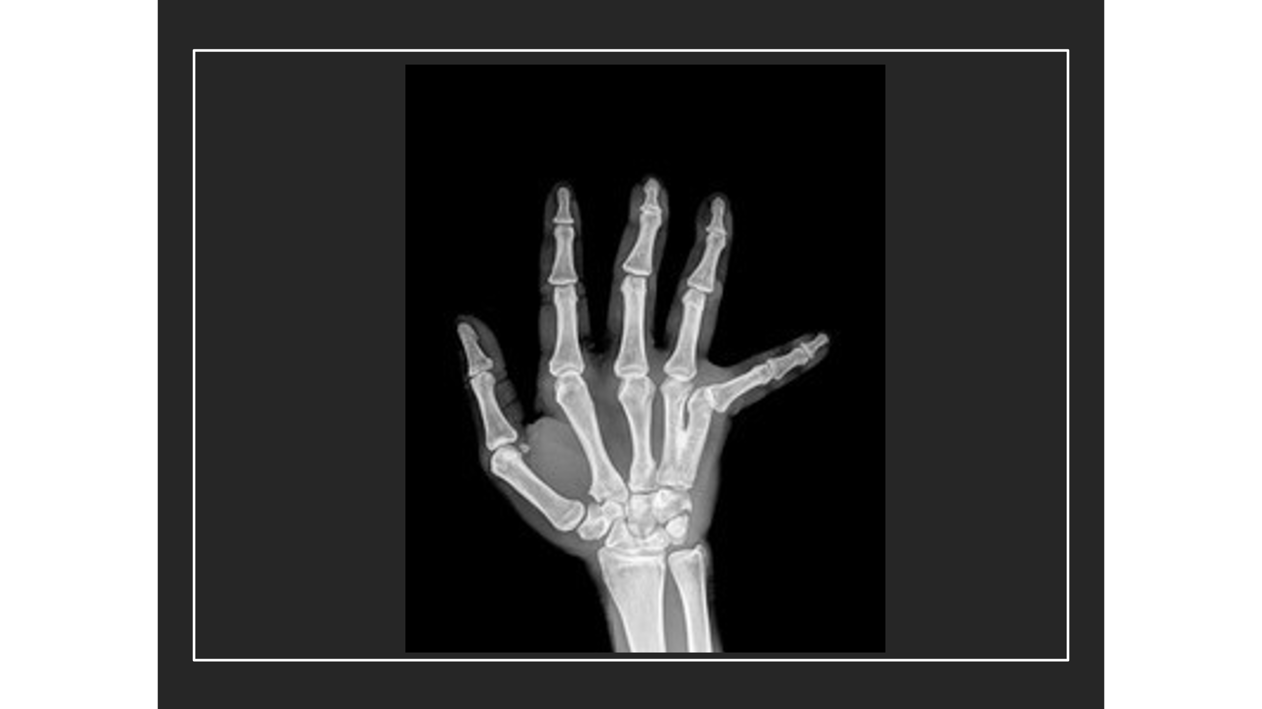 | Body part: Hand  Problem: Dislocated little finger  X-ray shows it is not broken  Needs to be popped back into the joint  Questions: Have any of you ever dislocated a joint. What happened? Did you have to go to hospital? Did it hurt when they popped it back? Was it quick? Much quicker than mending a broken leg that takes weeks!!!
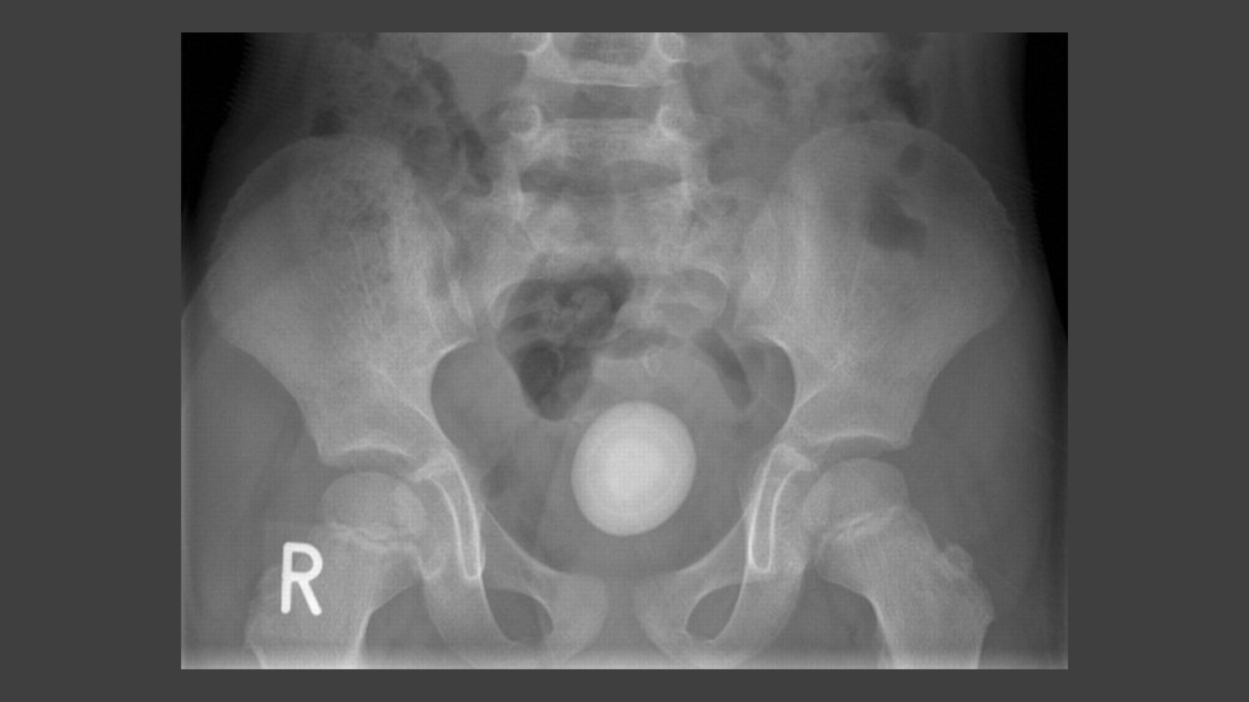 | Body part: Pelvis  Problem: there is a stone in the bladder  Very large bladder stone (you might explain how it got there using analogy of a pearl in an oyster shell, starting from one grain of sand building up to create a precious stone, and how this can happen in the bladder due to salts in wee!).  This patient probably has quite a bad tummy ache and might not be able to get their wee out.  Question: do you think this stone can come out all by itself? You can point out the small stones pass out in wee, but this is very big …  This could be blasted using ultrasound to break up the stone into little bits that it can pass out in the wee.
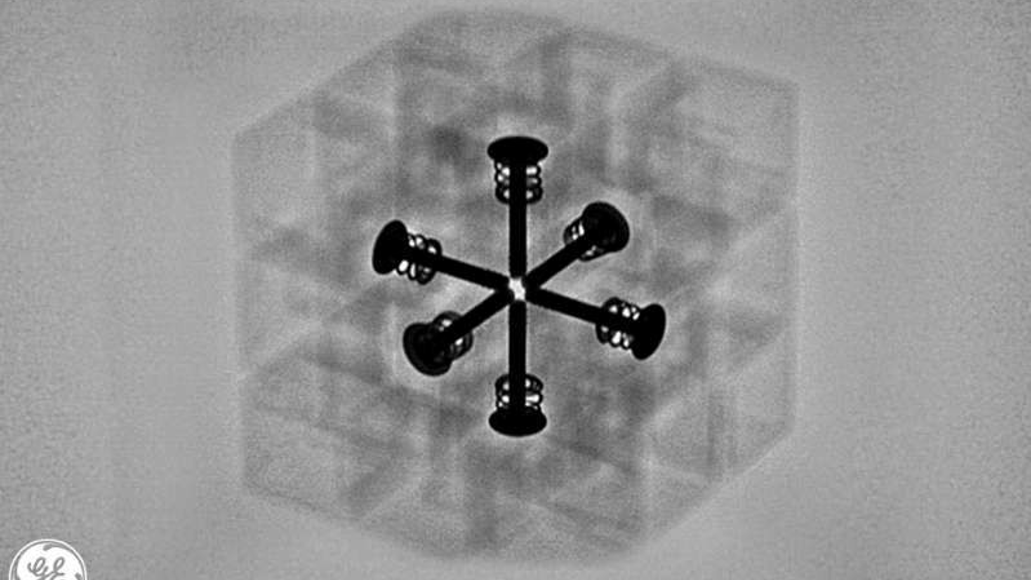 | Trick Image: It’s a Rubik’s Cube!  Black pins are the metal in the middle of the cube – these show up well because the metal is so dense  Around the pins are the plastic parts which are not as dense.
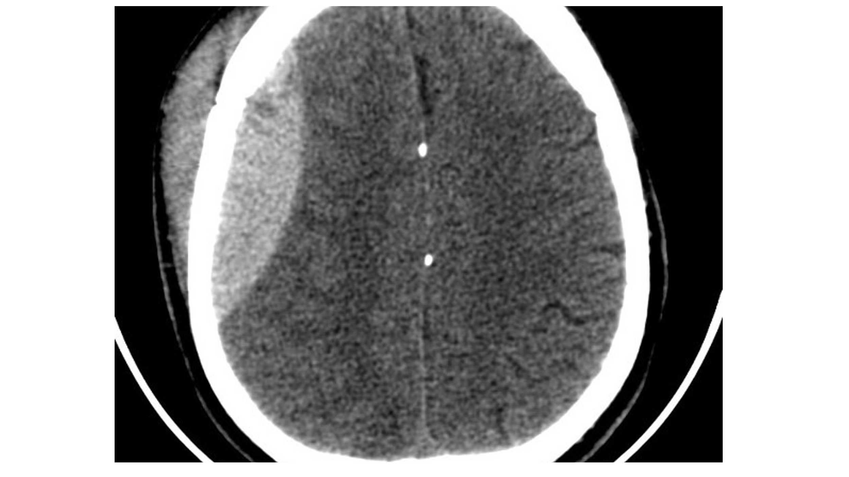 | Body part: Skull  Problem: head injury  This image is CT scan. It lets us see a slice through the brain  Point out brain and white bone of the skull  Point out bump on the head – on the outside the skull. This would be a big bump or a bruise. We would be able to see and feel it and it should go down all by itself in a few days.  But what about inside the skull? Point to the bleed inside the skull.  This is also a bruise (made by blood leaking out of the blood vessel and into the brain). This is a bleed on the brain and is much more dangerous as it has nowhere to go. Instead, it will squash the brain tissue and the brain is very sensitive. It doesn’t like to be squashed.  Explain that we need this picture so that the doctors can tell the situation is dangerous and do something about it.
Trick image: Cauliflower, or is it broccoli!

But it’s a lovely example of a 3D image

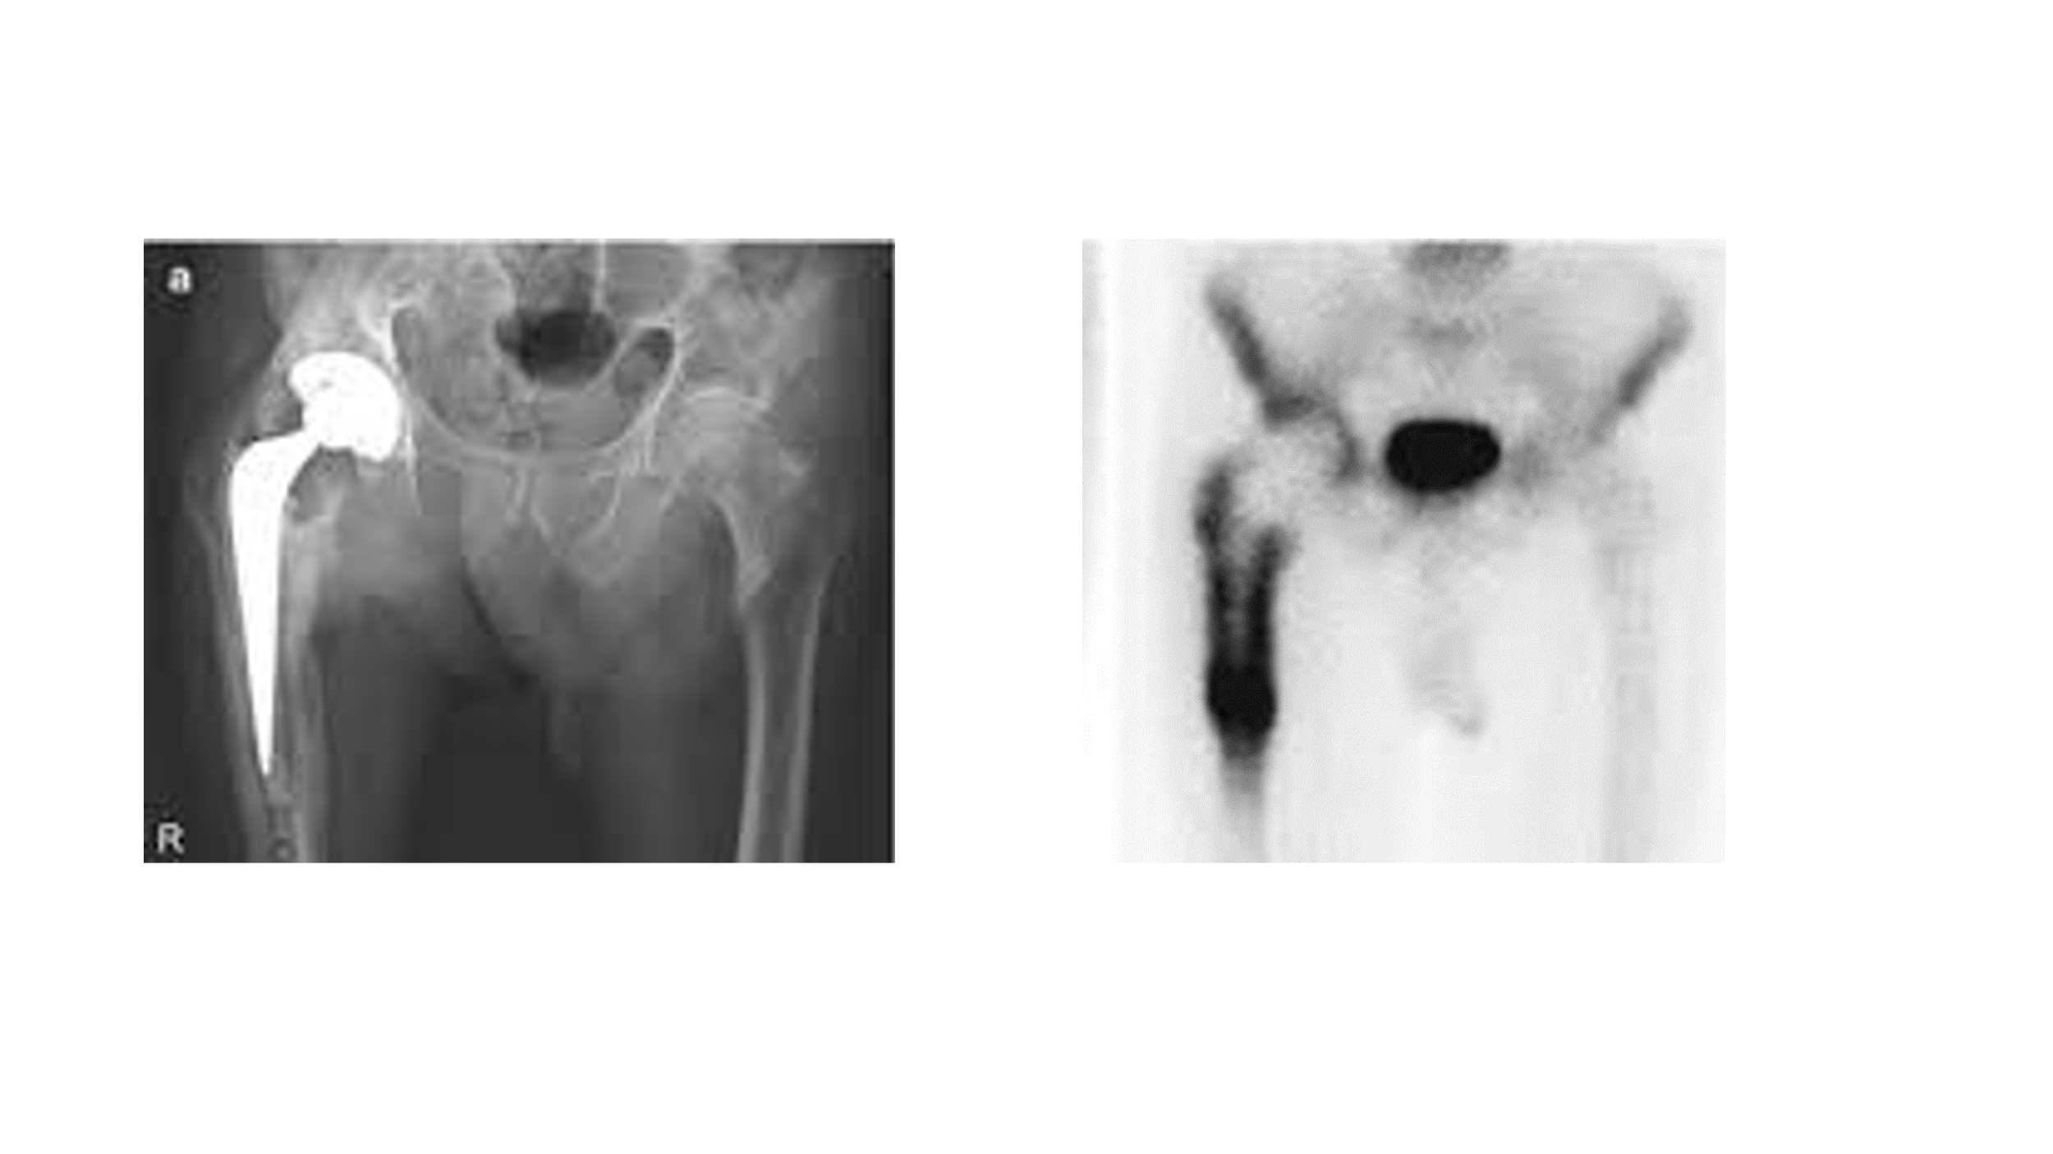 | Body part: Hip  Diagnosis: infected hip replacement  Point out that image on the left is an X-ray, like we’ve seen before, this time showing a hip replacement – you can see the metal of the hip joint.  On the right is a different type of test. This is a nuclear medicine scan and it much better at showing up infection than X-ray’s. This is done by making the blood radioactive – but just for a very short time!!!  Infection is greedy for blood and that why we can see more radiation where the infection is. This picture shows that the hip has become infected.
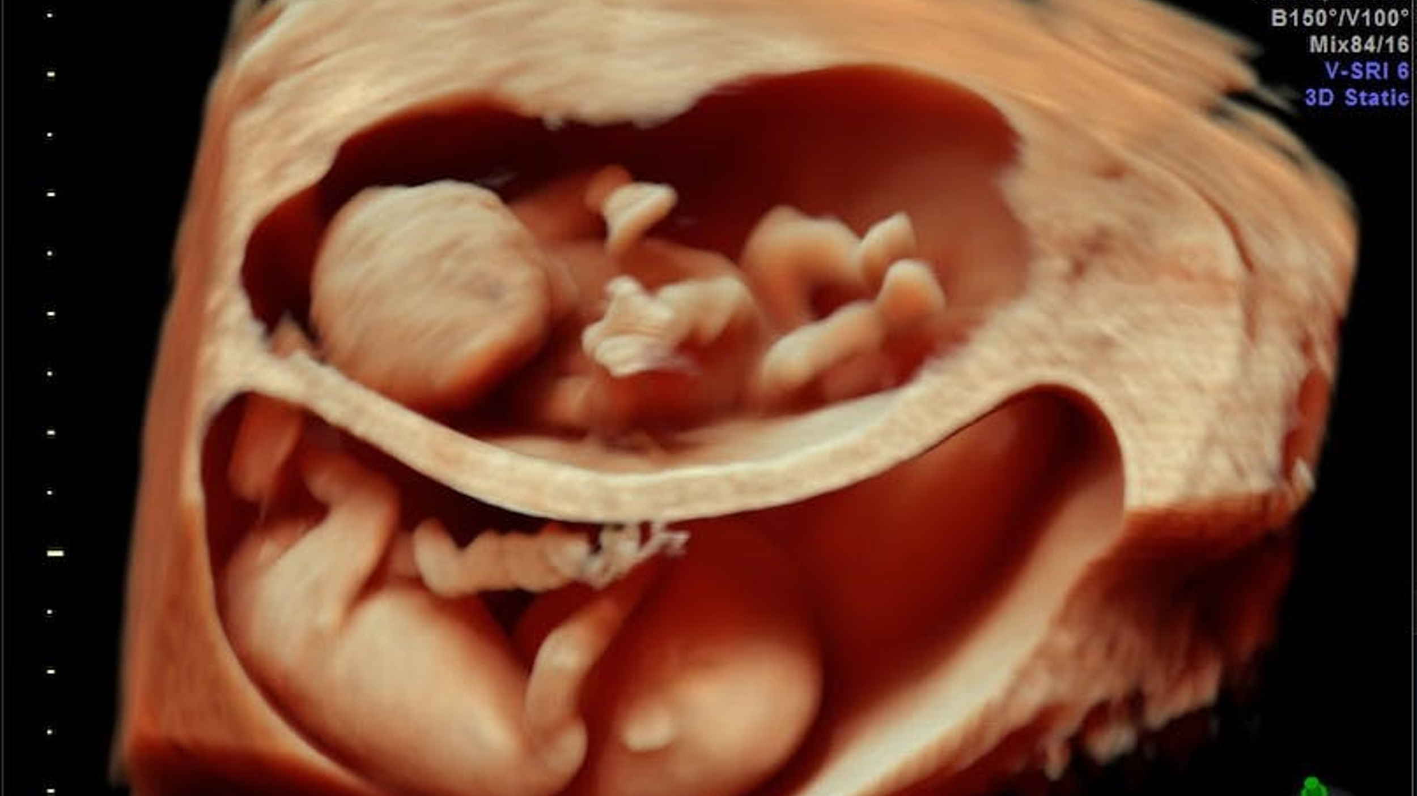 | The next 2 images are from an ultrasound scan.  Body part: womb/uterus/mummy’s tummy  Diagnosis: Twins!!  Point out both babies – feet, heads, umbilical cord to tummy button – how they get their food
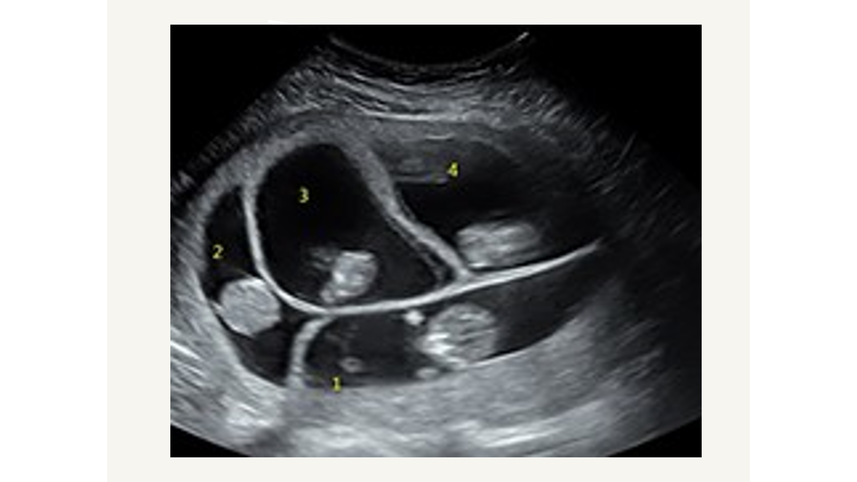 | Body part: womb/uterus/mummy’s tummy  Diagnosis: Quads!!!!!  Ask/explain why it’s good to know in advance if you are expecting lots of babies e.g. might be born small/early so you need 4 incubators ready. Might be safer to have a C-section – less traumatic for the babies. Parents will need to get 4 of everything! And time to get their heads around the idea. They are going to be busy!!!  Question: Do you know why we use ultrasound to look at babies rather than x-rays?  Ultrasound is safer as the x-rays could be harmful but also the ultrasound is better for picking up soft tissue so will see the babies more clearly.
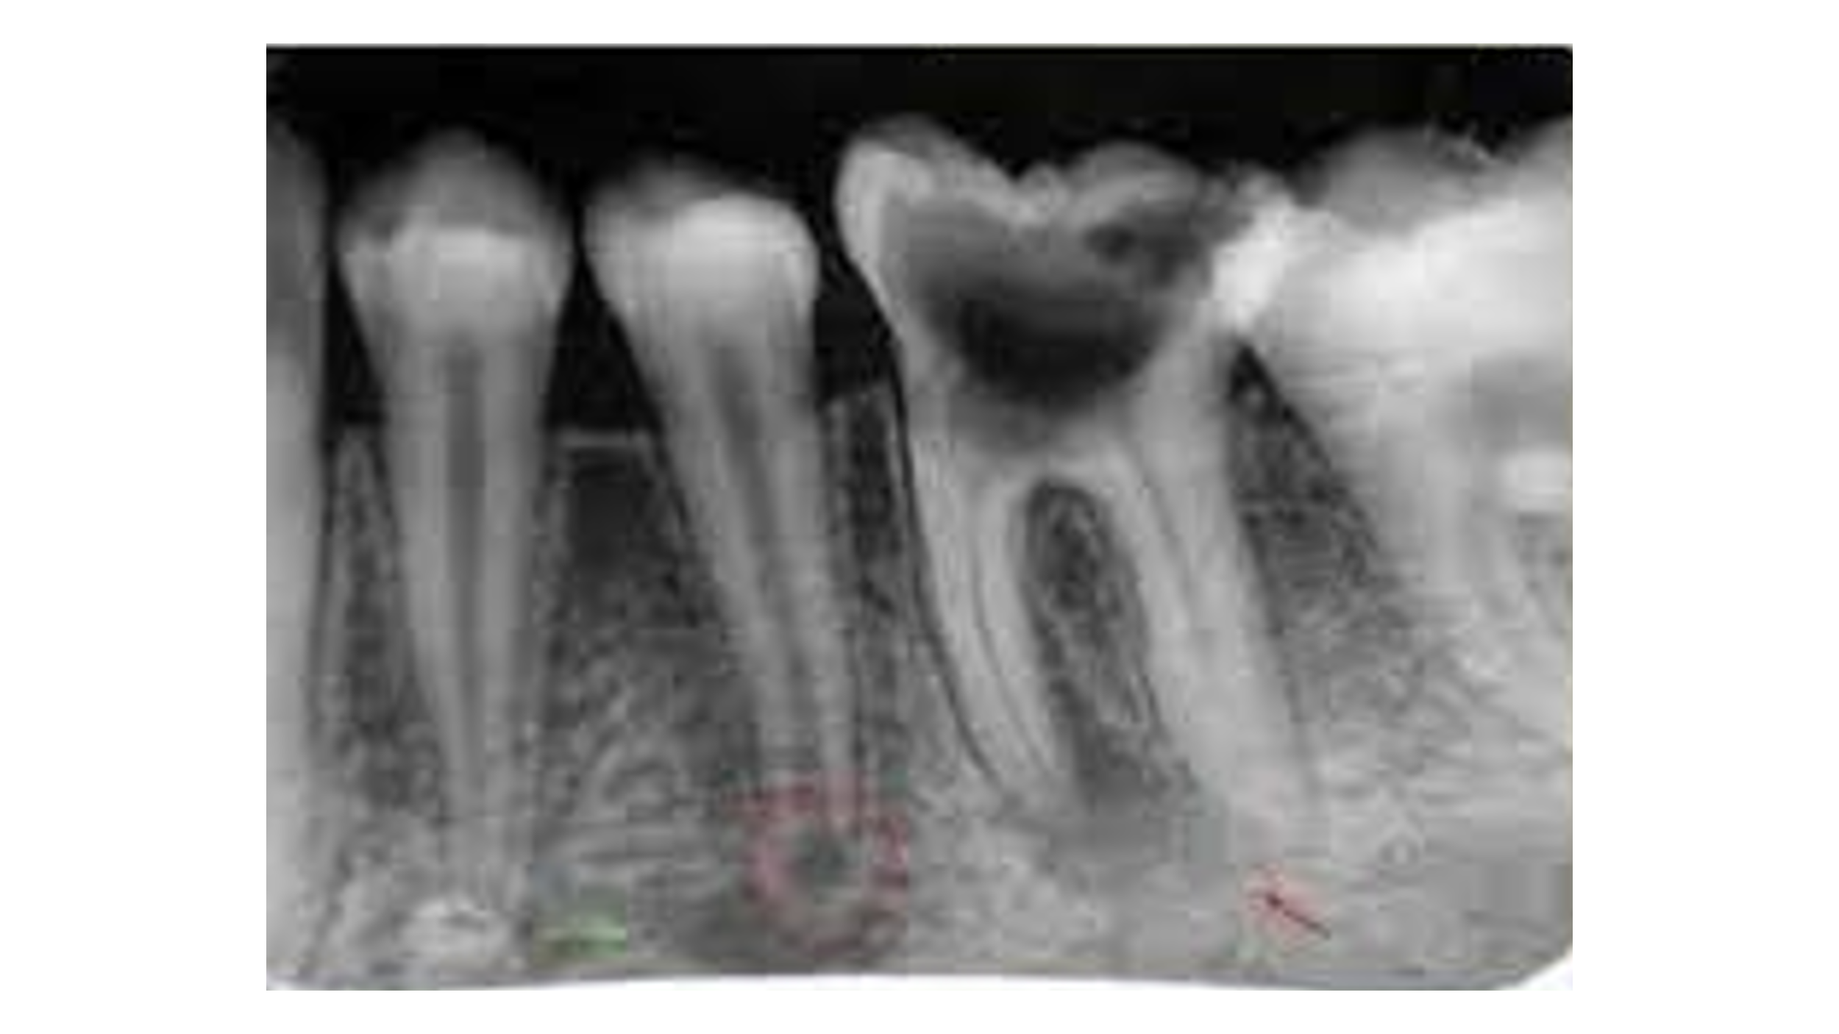 | Body part: Mouth/teeth  Diagnosis: cavity and root infection  May be taken by a Dentist or a radiographer  On the outside the big tooth might look ok. Point out on the x-ray it is black inside. This is a big cavity.  Also point out infection at the bottom where the red marks are.
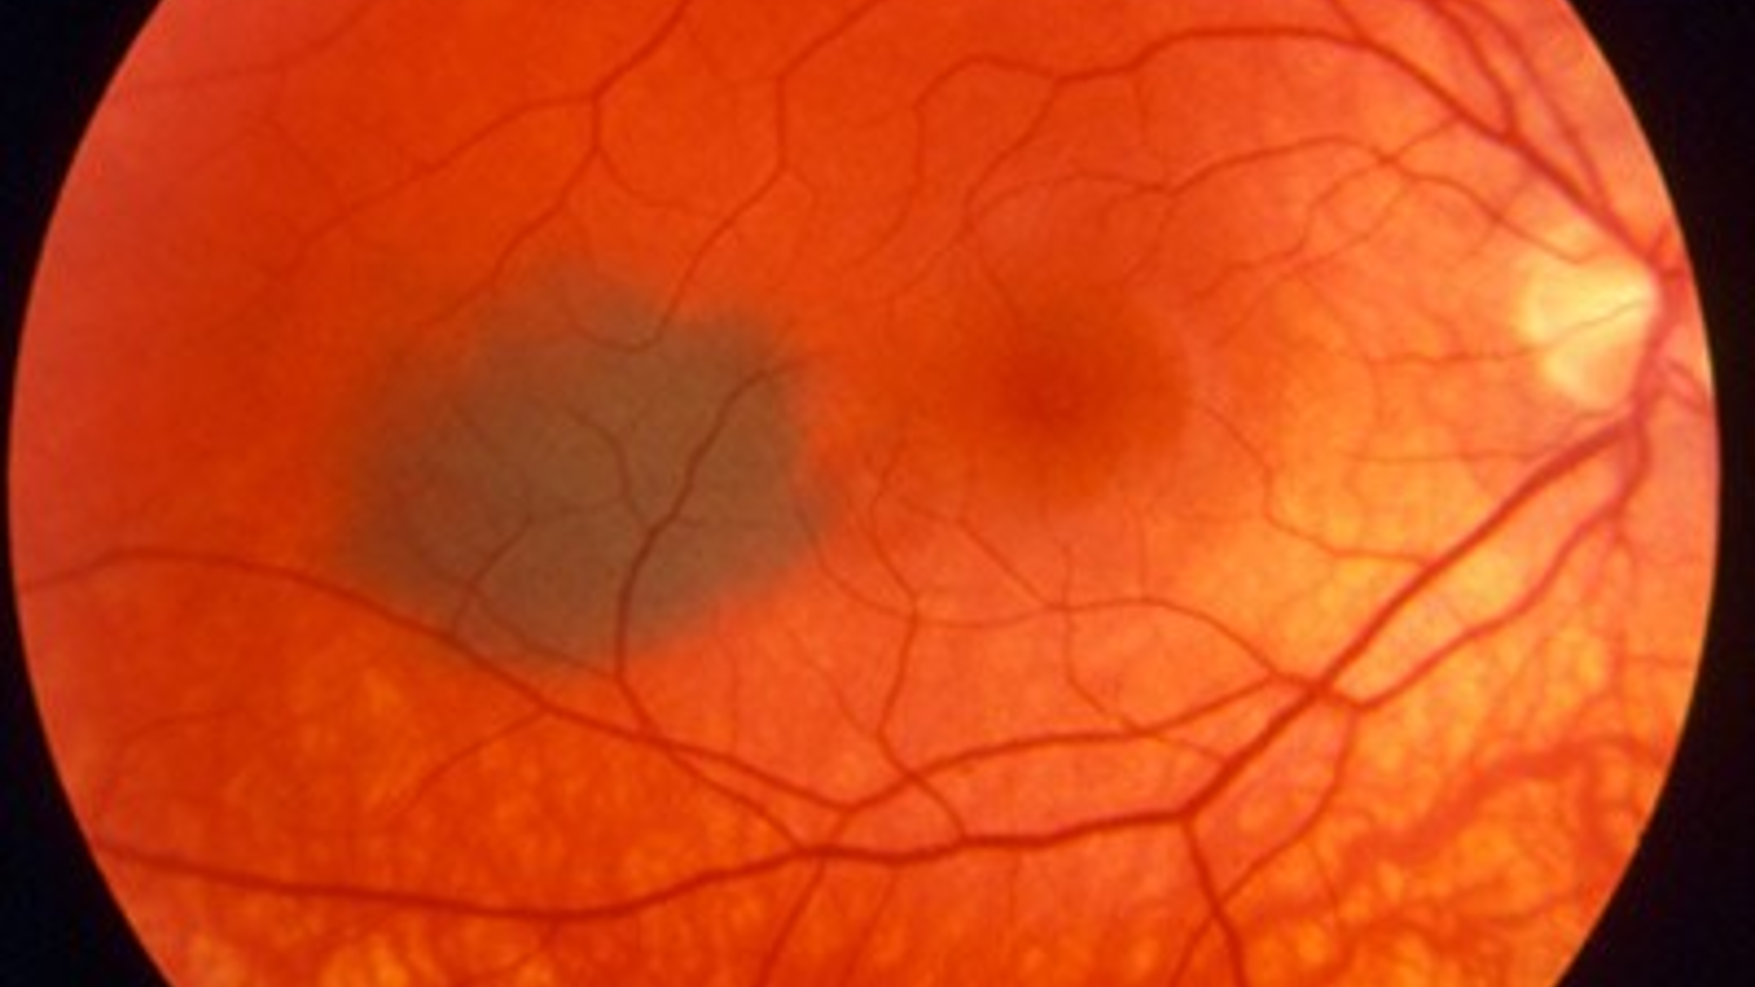 | Body part: back of the eye  Diagnosis: freckle  This is a photograph of an eye – uses light, just like an ordinary camera, not an x-ray or ultrasound.  Might be done by an optometrist.  Point out the blind spot where the nerves meet – on the right.  The darker/black mark is a freckle. Just like you might get a freckle on your skin. It is fine, it does not affect how you can see.

Closing the session
Tell the students that it is now the end of the session.
- Reflect on how they have been e.g. great at taking part, asking great questions or knowing stuff. Do you think they will make good healthcare scientists?

- Ask who now wants to be a Healthcare Scientist? Does anyone want to do any other type of job in Healthcare?

- Invite any last questions from the class: This could be general careers questions or more specific about the careers you have focused on.

- Invite any questions from the teacher: expect this to be about qualifications. You can explain that the first step is to do well in science, and maths and probably English too. Tell them that you went to university to study/ perhaps you had placements. Perhaps it was all scary at first but then you loved it.

