Experiences of workplaces | Job holder ambassador hints and tips Primary care

Giving an ambassador talk

This is you presenting about your job and your career journey. Limit it to around seven minutes and allow time for questions after. Successful ambassador talks are about understanding your audience and leaving out the details - the Q&A will allow further exchange of information.

Top Tips
- Look at your presentation or talk from the perspective of the learner. How old are they? Try to recall what you could take in and what you wanted to know that that age.

- Set objectives for the session. My three (I am a Vascular Sonographer) are usually:
- what do I do? to cover this I talk through one scan with lots of bright images and a video loop. I give the patient a name and a social story to make it relatable.
- why is my job important/why do I love it? I talk about the impact for the patient, how I help them, decision making/problem solving and how this makes me feel.
- link to STEM: e.g., how I use science to get the images and to understand what is going on in the patient’s body. And why I enjoy using science in my everyday work.

Please feel free to adapt these suggestions for your own role and story .

- Use your first name only and limit your title to the recognised occupation “I am John and I’m an optometrist,” “I am Hayley and I’m a sonographer.” Leave out complicated additions like senior, paediatric or educator. Or, provide an explanation.
- Describe your job using lay terms, perhaps using a case example or two.
- Deliver in the first person. “I” rather than “we.”
- Tell a story - your story.
- Pick highlights from your career journey but keep it truncated. It’s ok to talk about wrong turns. Very reassuring for students to hear how you got back on track.
- Mix media: PowerPoint is fine but aim for images, videos and use activities or props too.
- Use audience participation and Q&A whenever possible.
- If your presentation feels busy or rushed it’s time for an edit. If in doubt, leave it out 😊
- Do pre-warn students if you are talking about sensitive issues like cancer or suicide.

The don’ts:
- Avoid lots of text and small diagrams on slides and reading from slides.
- Try not list all the jobs you ever had or all the places you ever worked in the past.
- Avoid all jargon and abbreviations. If it’s unavoidable then offer an easy-to-understand explanation, but you will be surprised what you can leave out and keep the story alive.
- No need to mention all the other people you work with. Stick to your story about you.
- Don’t try to cover all the routes in - but do be prepared for questions about this.
- Young audiences are focused on their immediate next steps so no need to showcase all the places your career can lead to.

Fielding questions
Be prepared to field questions that might be outside your own sphere of expertise.

Top Tips
- Look for answers on-line, sharing how you do this with the learner.
- Use Health Careers website Health Careers to show where information about jobs can be found and encourage students to Take our careers quiz | Health Careers to help navigate and find the most suitable career choices for them.
- Use UCAS Search - UCAS to find university courses and to look at entry criteria.
- If you can’t find the answer, take their career leads or parents e-mail, and use that to pass on information once you have had chance to consult your peers.

Reaping the benefits of being a career ambassador
It can be part of your own growth, development and even support revalidation.

You might apply Gibbs reflective cycle to you career ambassador practice:

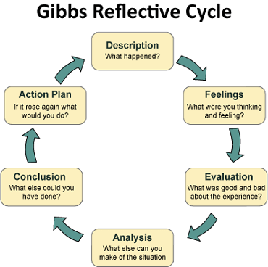

Like everything in our professional lives, it gets easier and more comfortable with practice.

I hope you get lots of rewards from inspiring and supporting the next generation workforce.

